# 2 Detailed

## 2.1 Goal

This project is going to consist of a homepage that has 25 personality-based questions which when answered completely will then take the user to another webpage, within Marvel.lmu.build, where it will then tell the user what their Meyer-Briggs Type Indicator (MBTI) is. MBTI is composed of a four-letter acronym where each letter can vary between two different letters (its dimension) giving a user a total of 4^2 (16) personality types. The user’s MBTI will also illustrate a marvel character which also shares the same MBTI and other non-marvel characters as well. The potential users for this Marvel personality website will mostly consist of (i) fans of Marvel and (ii) people who have watched something Marvel-related. SCRUM, which is an Agile methodology, is being used as a program management style when completing this project. By applying SCRUM, the team is able to partition the completion of the project into sprints. Each sprint consists of a burndown plan which shows how much work has been completed at each given sprint compared to what was planned.

### 2.1.1 Style

For SCRUM, the team consisting of four people will be assigned a role. There are currently three roles that can be served for this project:

1. Product Owner
2. SCRUM Master
3. Developer

Of the four team members, two will serve as developers. After each sprint, the roles will then switch. Each sprint consists of two weeks or 10 working days. There will be three sprints for this project.

|  |  |  |  |
| --- | --- | --- | --- |
|  | Sprint # | | |
| Role | 1 | 2 | 3 |
| Scrum Master | Mark | Brandon | Alejandro |
| Product Owner | Brandon | Alejandro | Brendan |
| Developers | Alejandro | Brendan | Mark |
| Developers | Brendan | Mark | Brandon |

### 2.1.2 Potential users

The purpose of this project is to assist fans or potential fans of Marvel to determine what their MBTI is. Therefore, this project will be meant for the following people:

1. Fans of Marvel
2. People who have watched something Marvel-related.

Despite this project being meant for the two aforementioned types of people, it can also catch the attention of the following people:

1. LMU Students
   1. Curious
   2. Random website searchers/surveyors
   3. Classmates
2. Professional Competitive Survey Takers
3. The FBI (not the NSA or CIA, sorry)
4. MBTI enthusiasts

## 2.2 Project Requirements

Epics, which are larger stories, will be broken down in this section to allow them to be simplified and distributed appropriated into sprints for completion. Epics will be shown as “EPIC:” while its simplified broken-down child stories will be shown as “child” followed by a number (e.g., “Child1”, Child2”, Child3”).

### 2.2.1

EPIC:

As a Marvel Fan, I want to be able to identify which of the 16 Meyer’s Briggs Personality Types I am, so that I can compare it to which Marvel character shares that same personality.

Child1:

As a Survey Taker, I want there to be 16 Meyer’s Briggs Personality Types for this survey, so that I can fall in any of the MBTI categories.

Child2:

As a Marvel Fan, I want each MBTI to fall into a specific Marvel character, so that I can see which Marvel character I am most similar to.

### 2.2.2

EPIC:

As a survey taker, I want to be able to be redirected if my results are inconclusive, so that I do not feel left out.

Child1: As a survey taker, if I do not answer all the questions, I want to be redirected to take the quiz again, so that I can be given a Marvel character personality type.

Child2: As a survey taker, I want to see if I missed any questions after submitting, so that I can see if I forgot to answer any of the questions.

### 2.2.3

EPIC:

As a Marvel Fan, I want to respond to 25 questions, so that there is enough information to assess what Marvel personality I am.

Child1:

As an MBTI enthusiast, I want to have 25 questions, so that each MBTI dimension has a total of 6 questions minimum.

Child2:

As a Marvel Fan, I want to answer 25 questions, so that the collected information has distinguished which Marvel personality I am.

Child3:

As a developer, I want to be able to distinguish each of these questions into an MBTI dimension, so that I can appropriately assign the personality type to the user.

### 2.2.4

EPIC:

As a Marvel Fan, I want there to be a minimum of 16 marvel superhero personality types, so that I know that my personality type is not limited.

Child1:

As an MBTI enthusiast, I want there to be 16 marvel superhero personality types, so that each character reflects an accurate number of MBTI personality types.

Child2:

As a Marvel Fan, I want to have 16 marvel characters possibilities to get, so that I can sense a variety of Marvel profiles.

### 2.2.5

EPIC:

As a fiction fan, I want there to be non-marvel character comparisons after receiving my results, so that I may know which other fictional characters share similar personalities.

Child1:

As a fiction fan, I want to see a list of non-marvel characters that match my personality traits, so that I can explore new characters that I may not have considered before.

Child2:

As a fiction fan, I want to be able to filter the list of non-marvel character comparisons, so that I can more easily find characters that align with my interest.

### 2.2.6

Child (no breakdown needed):

As a Marvel Fan, I would like there to be a graphic of my personality, so that I can see what the Marvel character looks like.

2.2.7

EPIC:

As a Marvel fan, I want to be able to take the personality test again in the future, so that I can see if my personality type changes over time.

Child1:

As a Marvel fan, after completing the survey and receiving my answers I want to be redirected to take the test again if I would like, so that I can get a different personality type.

As a developer, I will provide a button or area which the user can select, so that they take retake the survey.

2.2.8

EPIC:

As a Marvel fan, I want to be able to share my results with others, so that I can see if my friends also have marvel characters with the same personality as me.

Child 1:

As a Marvel Fan I would like to be able to copy and text the results of the personality test to other friends who are also Marvel fans.

Child 2:

As a Marvel Fan I would like to be able to post or share the results of the personality test on social media for others to see and comment on.

As a developer I want to provide some button for the users to link the results page to their social media or send as a message over text.

## 2.3 Preliminary Design Description

After taking the survey the user will be given results which tells them which personality they fit best.

* The first character of the personality survey tells the user whether they are Introverted (I) or Extroverted (E).
* The second character of the personality survey tells the user whether they are sensing (S) or intuitive (N).
* The third character of the personality survey tells the user whether they are thinking (T) or feeling (F).
* The fourth character of the personality survey tells the user whether they are judging (J) or perceiving (P).

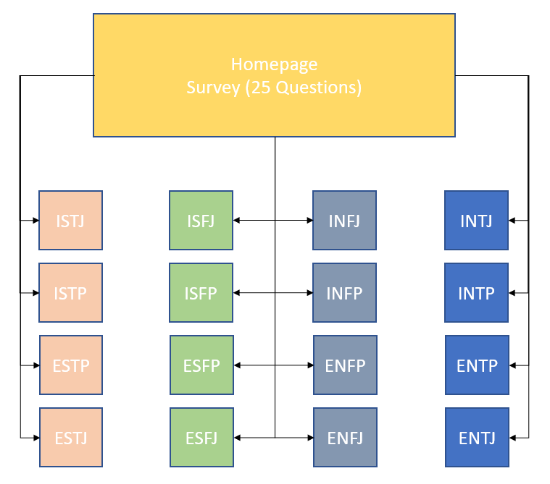

Each result page after taking the personality test will consist of the following page:

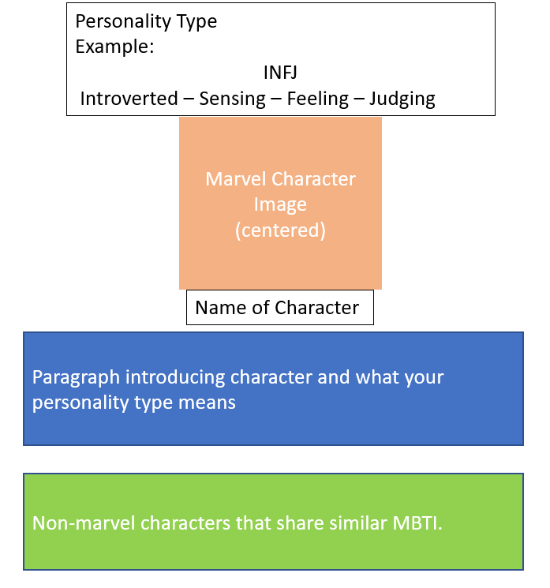

Illustrated below is the current homepage that consists of 25 questions of the Marvel.lmu.build website that consists of a Marvel header followed by 25 questions:

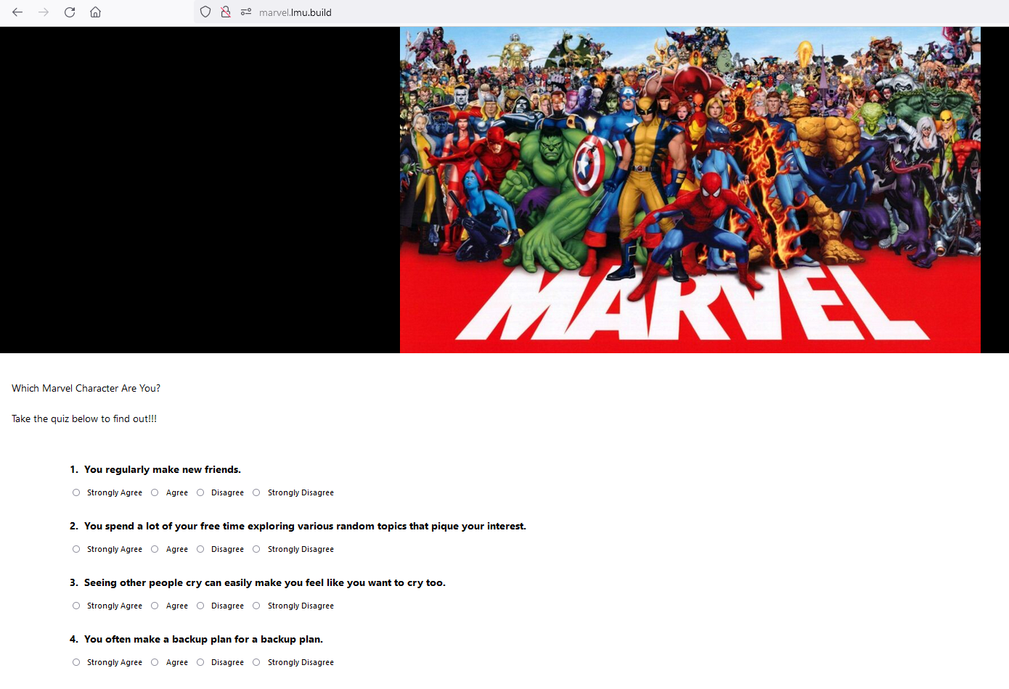

## 2.4 Preliminary Development Schedule

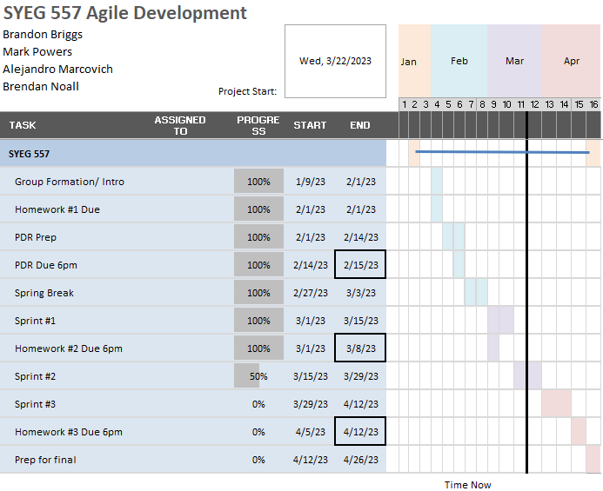

## 2.5 Project Status

The front-end development of the homepage has been completed, which might require minor aesthetic changes if needed. At the backend of the homepage, a majority of the design work has been completed for appropriate separating each question into its appropriate four MBTI dimensions (e.g., E or I, N or S, F or T, etc.). On top of this, the list of characters and the paragraph introducing each character and the user’s personality type have been designed, which now only requires implementation onto a user page. Currently what needs to be completed is creating a single page for an MBTI and then using that as the template to copy and paste to develop the other pages.

### 2.5.1 Burndown Plan

Sprint 1:

Starting work: Day 1 (5 story points)

Planned completion: Day 10 (5 story points)

Actual Completion: Day 7 (10 story points remaining)

Sprint 2:

Starting work: Day 11 (5 story points)

Planned completion: Day 20 (5 story points)

Actual Completion: Day 17 (5 story points remaining)

Sprint 3:

Starting work: Day 21 (5 story points)

Planned completion: Day 29 (5 story points)

Actual Completion: Day 27 (0 story points remaining)

Overall Project burnup Plan:

Planned Work: 15 story points

Actual Work Completed: 5 story points

Remaining work: 10 story points

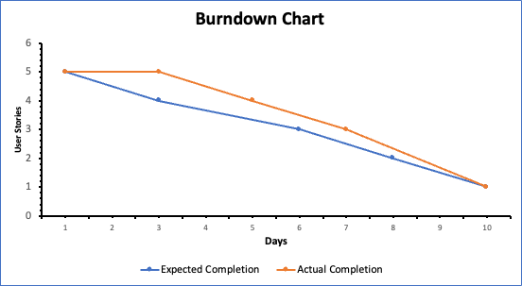

### 2.5.2 Burnup Plan

